 

DATABASE COURSEWORK

Runisi Nikoya Samaranayake

IIT NUMBER - 20221247

RGU NUMBER - 22370278

contents

1.Conceptual Entity relationship Diagram(Question 1) ……………………………………… 03

1. Assumptions made for EERD …………………………………………………………. 04 - 05
2. Logical Relational Schema (Question 2) …………………………………………………………. 06
3. Normalization ……………………………………………………………………………………………….. 07
4. SQL codes for normalized relational schema(Question 3) ………………………………. 08 - 20
5. Database Diagram Generated…………………………………………………………………………. 21
6. Generating Suitable SQL Queries (Question 4) …………………………………………………21 - 24

**Conceptual Entity-Relationship Diagram (ERD/EERD) (question 1)**

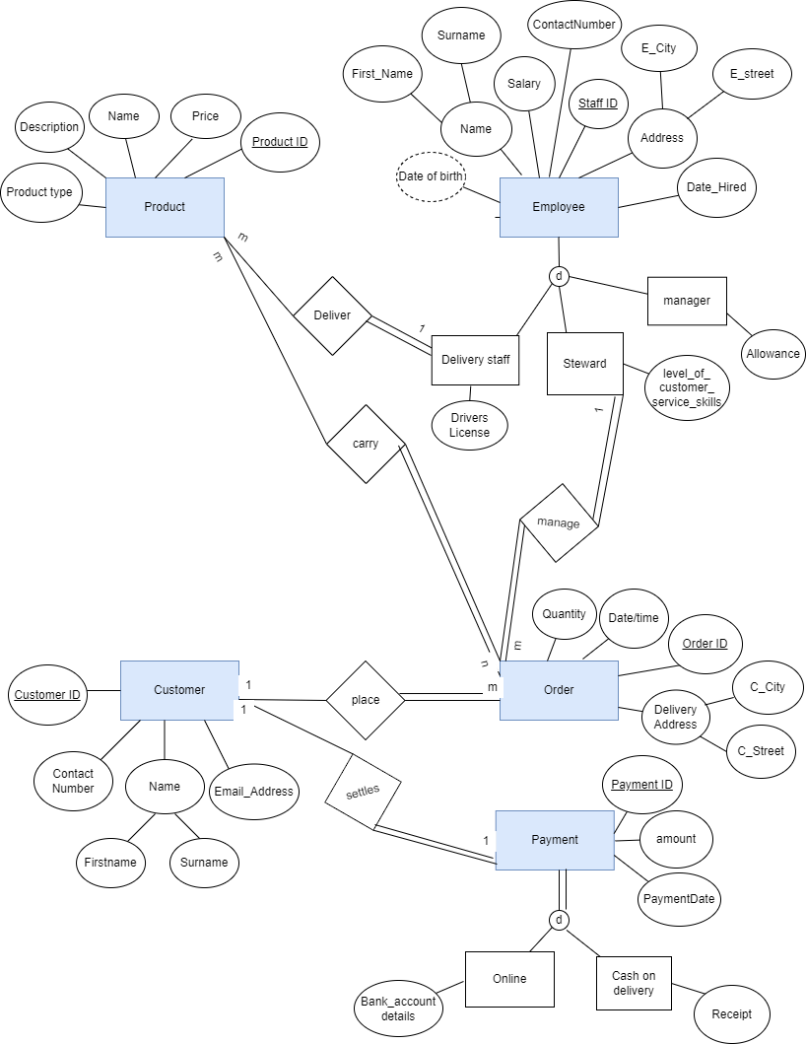

ASSUMPTIONS made for eerd

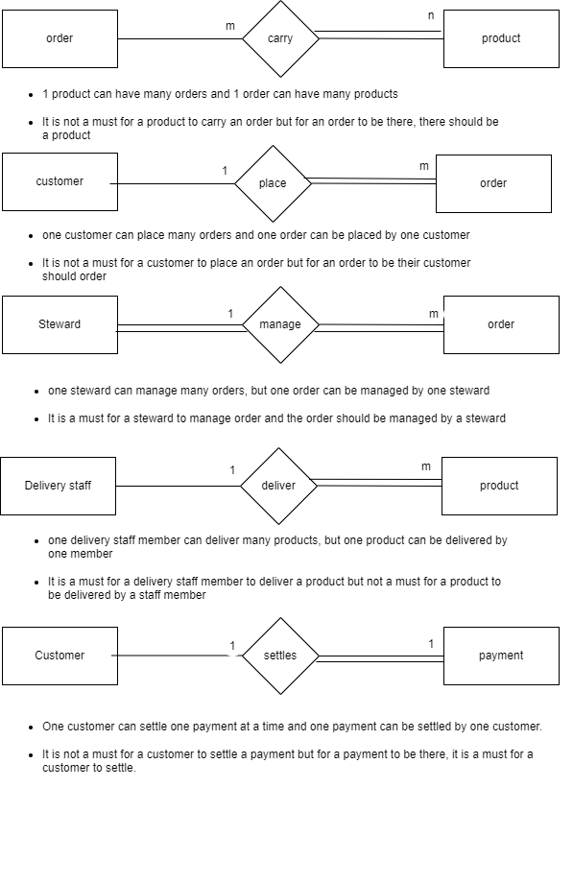

ASSUMPTIONS CTD…

* For an employee, it has delivery staff, a manager, and a steward, but it can have other categories of staff such as chef, cashier, technician, etc., so it's OPTIONAL. and also, an employee can be a delivery staff member or a manager, or a steward, so it doesn't overlap Therefore it's OPTIONAL(OR).
* For payment, it can be divided into online and cash-on-delivery, Payment can have only these 2 options, and also payment can be done either online or cash on delivery therefore it's MANDATORY (OR).
* And considered contact number, not as a multi-valued attribute as a customer will give one number to contact so it's not a multi-valued attribute.
* And for contact number in employee it was not considered as an Multi valued attribute as I assumed that each employee will have one Contact Number for working purposes which is provided separately from the cafe.
* Since manager and supervisor is the same, Supervisor was not considered as a separate entity, Hence a relationship was too not considered.

**Logical Relational Schema (question 2)**

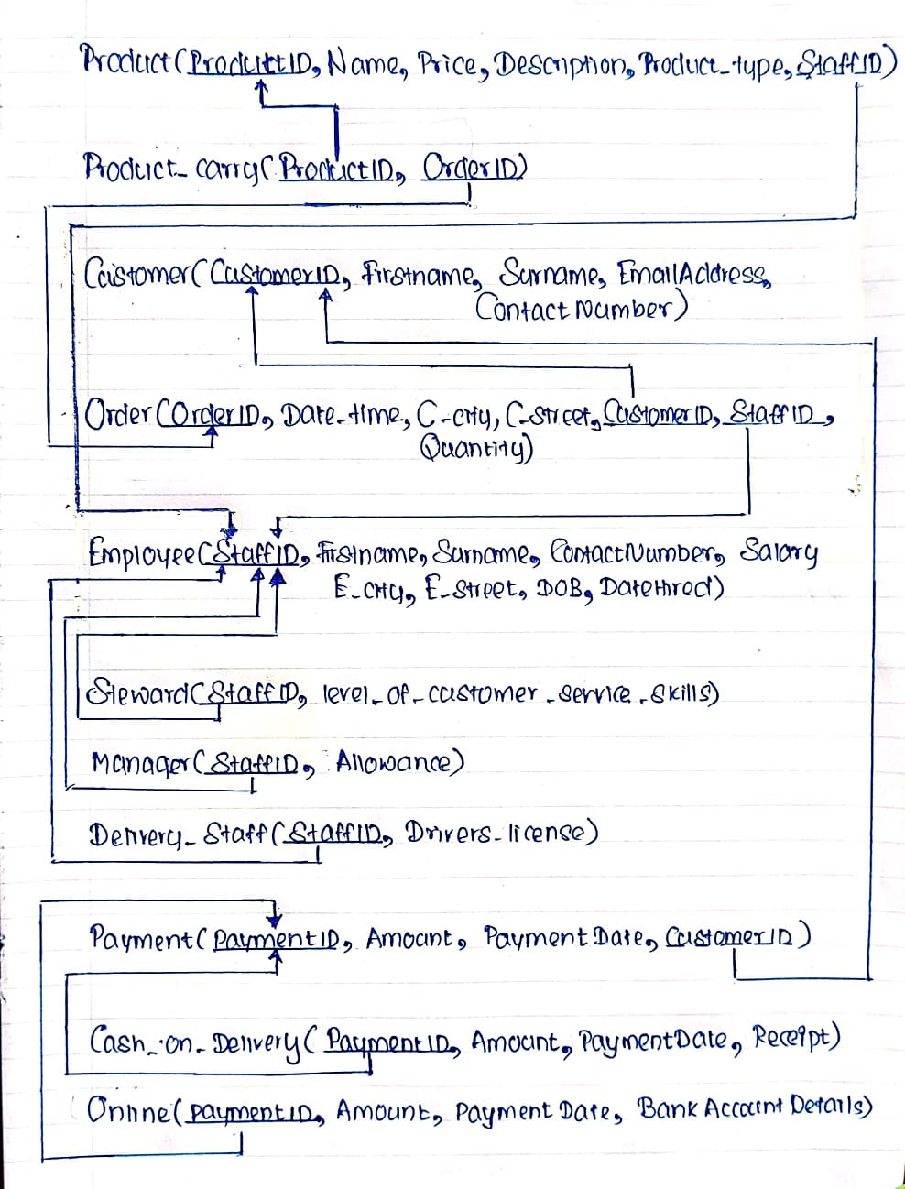

**Normalization**

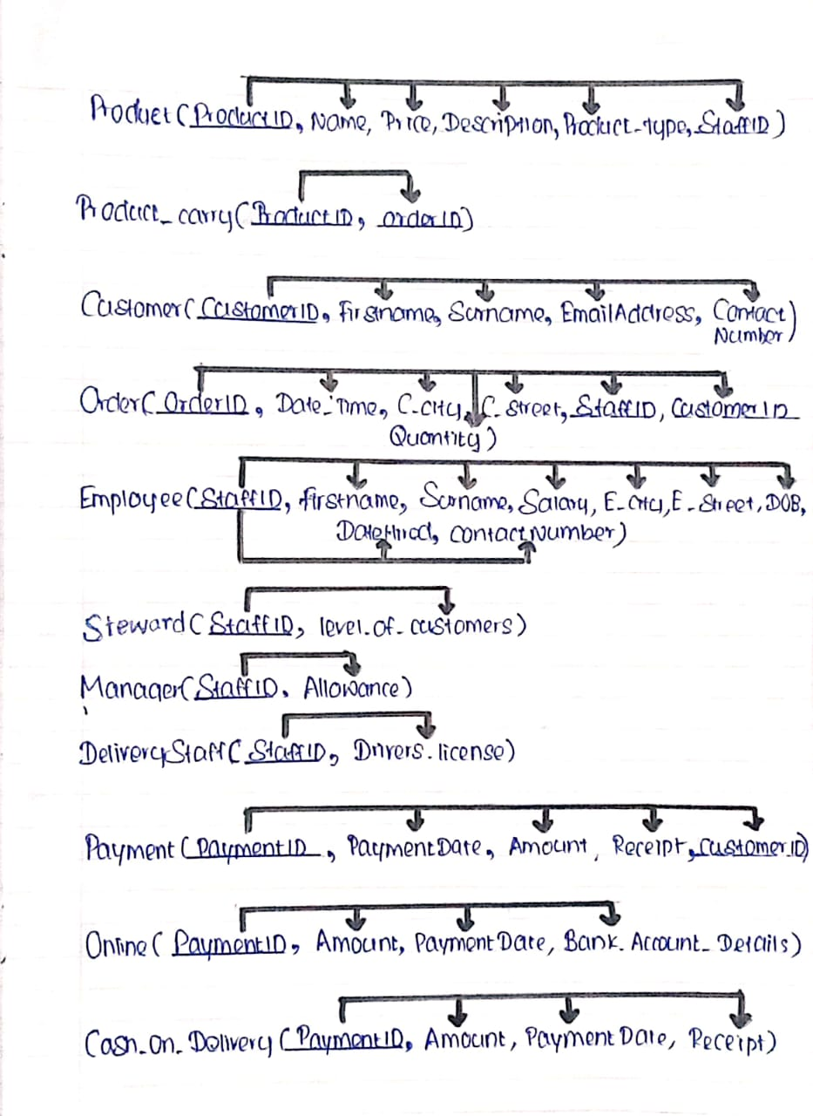

**Normalization ctd..**

* All the above tables are in the normalized form .
* All the above tables have no repeating groups and no multi valued attributes and composite attributes therefore its in 1NF.
* All the tables have no partial dependencies since all the tables have fully functional dependencies therefore its in 2NF.
* All the tables have no transitive dependencies therefore its in 3NF.

SQL CODES FOR THE NORMALIZED RELATIONAL SCHEMA (question 3)

1. Product (ProductID, Name, Price, Description, Product_Type, StaffID)

CREATING THE TABLE

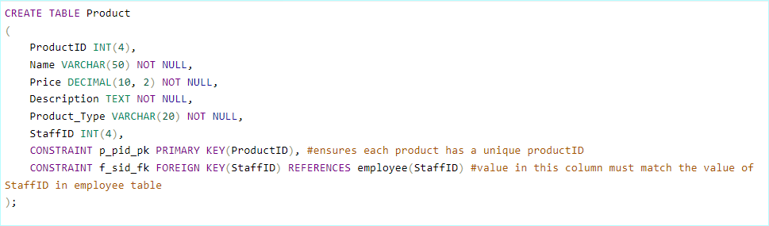

INSERTING VALUES

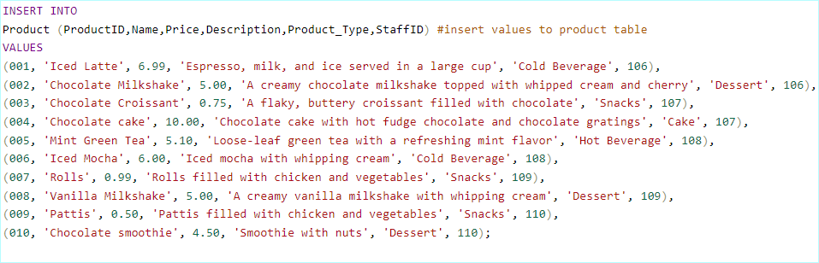

FINAL TABLE FOR PRODUCT

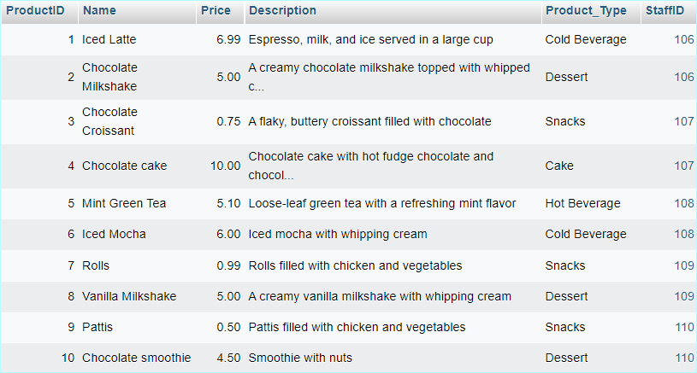

1. Employee(StaffID, Firstname, Surname, ContactNumber, Salary, E_city, E_street, DOB, Date_ Hired)

CREATING THE TABLE

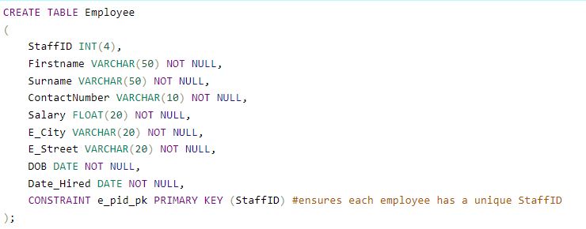

INSERTING VALUES

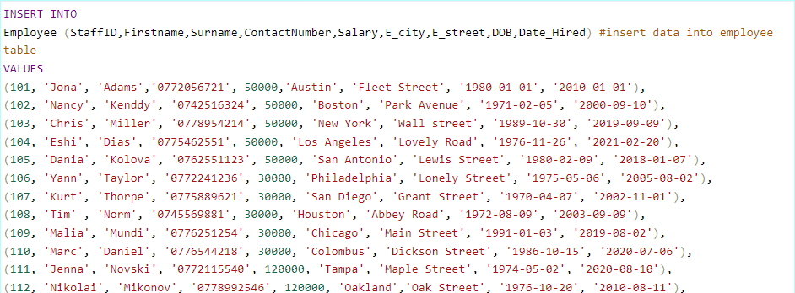



FINAL TABLE FOR EMPLOYEE

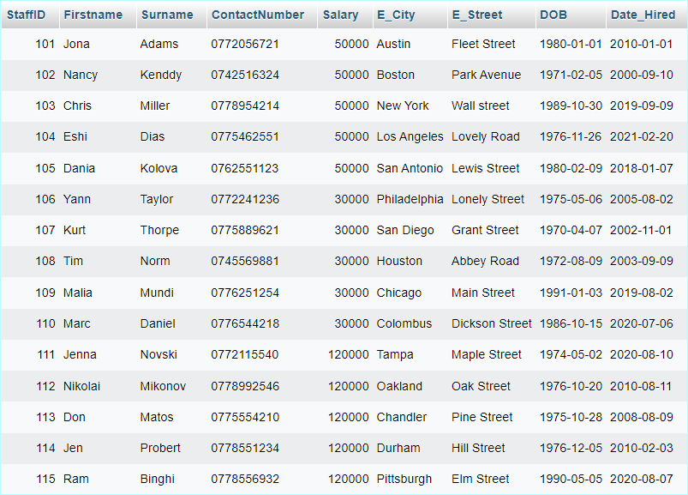

1. Steward (StaffID, level_of_customer_service_skills)

CREATING THE TABLE

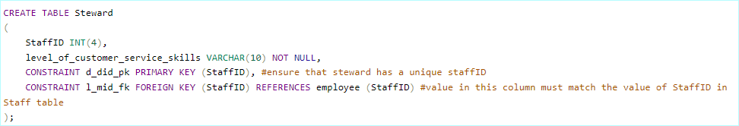

INSERTING VALUES

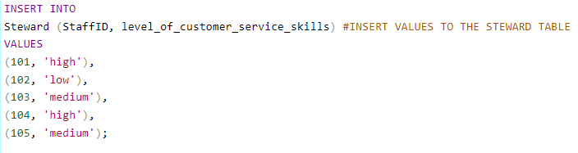

FINAL TABLE FOR STEWARD

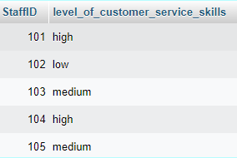

1. Manager (StaffID, Allowance)

CREATING THE TABLE

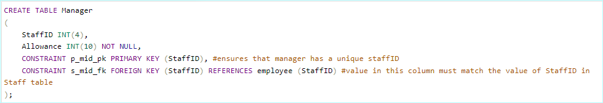

INSERTING VALUES

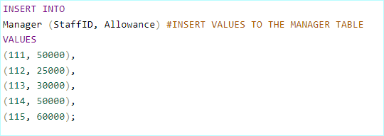

FINAL TABLE FOR MANAGER

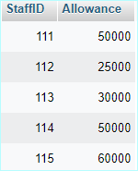

1. DeliveryStaff (StaffID, Drivers_license)

CREATING THE TABLE

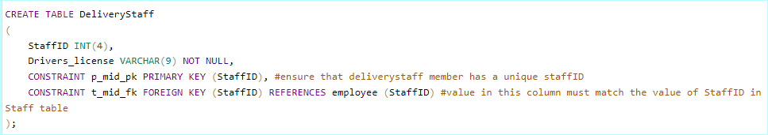

INSERTING VALUES

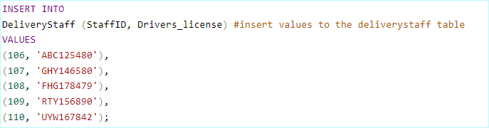

FINAL TABLE FOR DELIVERY STAFF

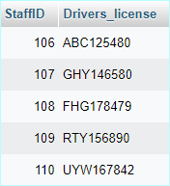

1. Customer (CustomerID, Firstname, Surname, Email_Address, ContactNumber)

CREATING THE TABLE

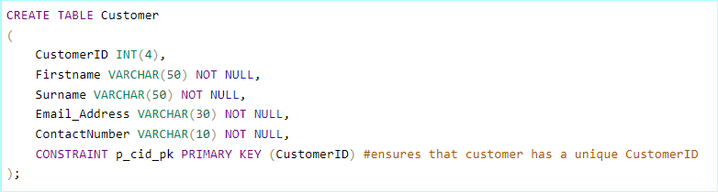

INSERTING VALUES

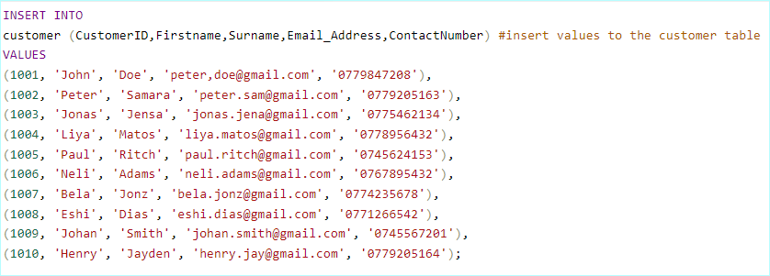

FINAL TABLE FOR CUSTOMER

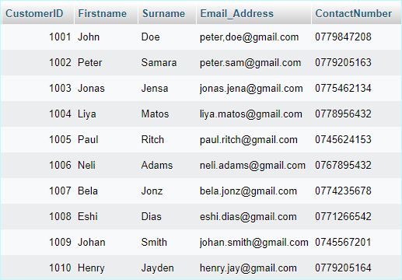

1. Ordert (ordertID, Date_Time, C_City, C_Street, Quantity, StaffID, CustomerID)

CREATING THE TABLE

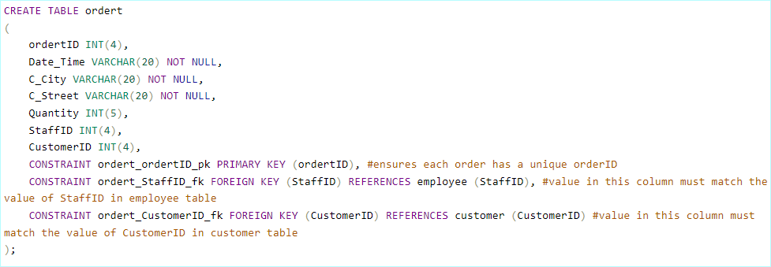

INSERTING VALUES

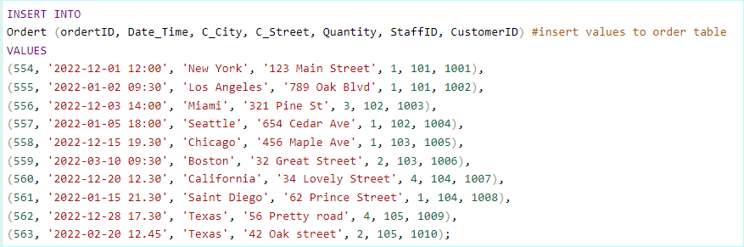

FINAL TABLE FOR ORDER

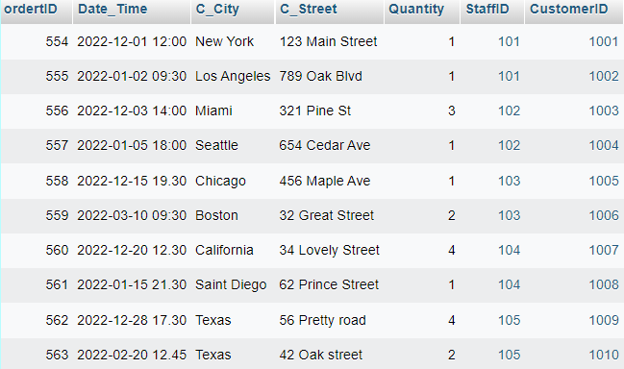

1. Product_carry (ProductID, OrdertID)

CREATING THE TABLE

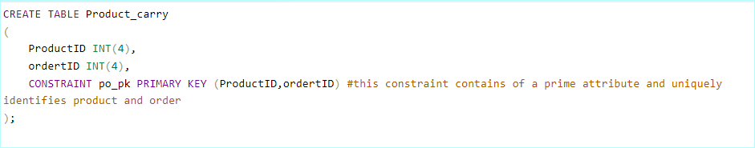

INSERTING VALUES

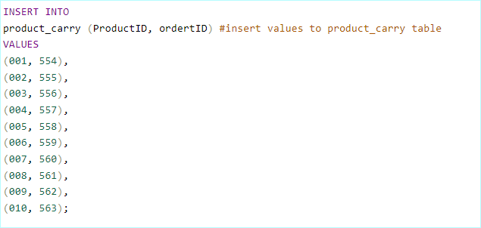

FINAL TABLE FOR PRODUCT_CARRY

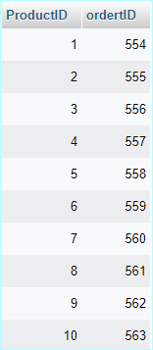

1. Payment (PaymentID, CustomerID, Amount, PaymentDate, CustomerID)

CREATING THE TABLE

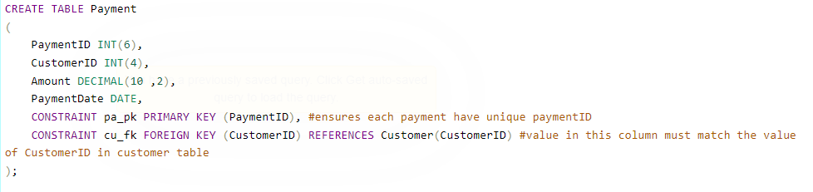

INSERTING VALUES

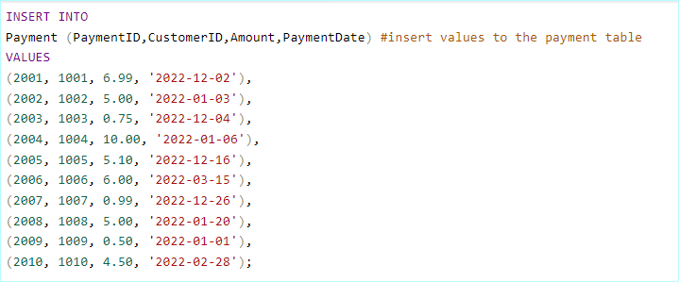

FINAL TABLE FOR PAYMENT

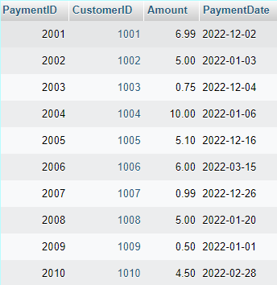

1. Online (PaymentID, Amount, PaymentDate, Bank_Account_Details)

CREATING THE TABLE

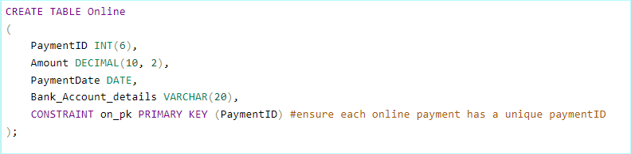

INSERTING VALUES

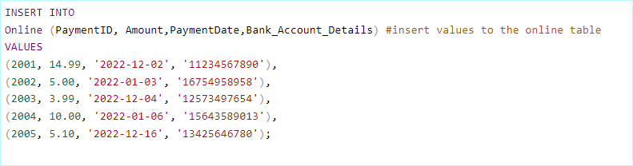

FINAL TABLE FOR ONLINE

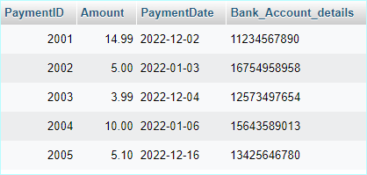

1. Cash_on_Delivery (PaymentID, Amount, Receipt, PaymentDate)

CREATING THE TABLE

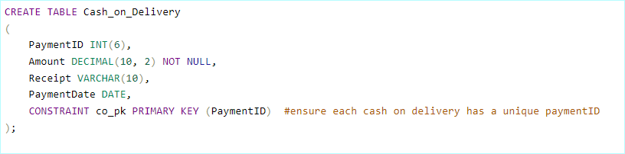

INSERTING VALUES

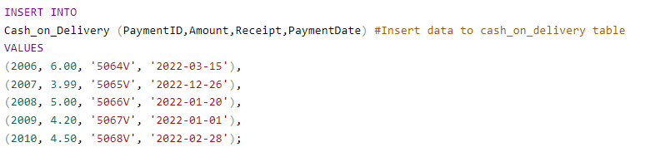

FINAL TABLE FOR CASH_ON_DELIVERY

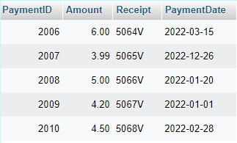

**database diagram generated**

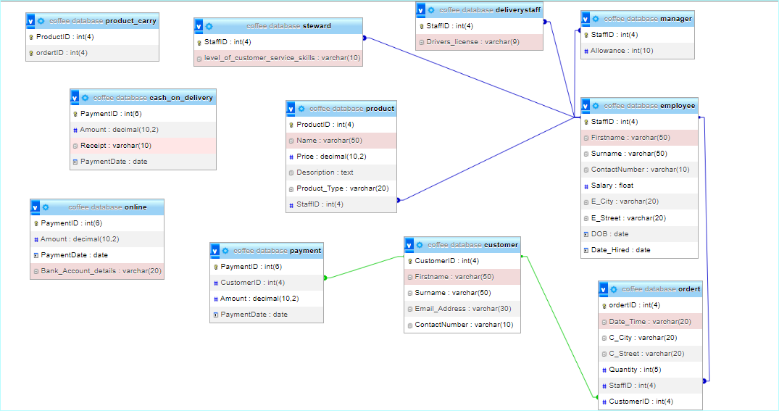

GENERATING SUITABLE SQL QUERIES (QUESTION 4)

**PART A**

SQL QUERY

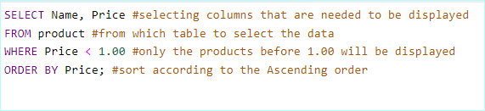

OUTPUT

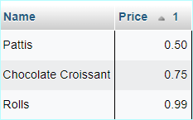

**PART B**

SQL QUERY

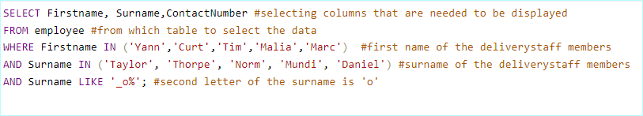

OUTPUT

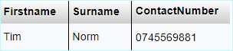

**PART C**

SQL QUERY

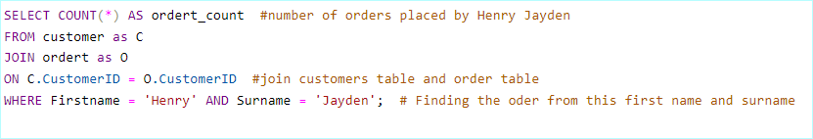

OUTPUT

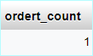

**PART D**

SQL QUERY

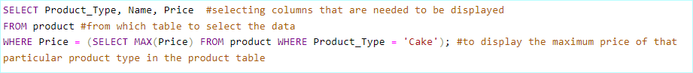

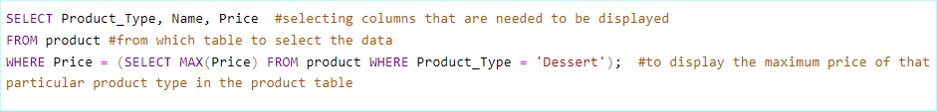

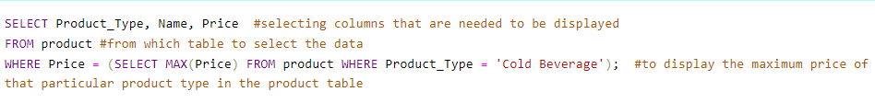

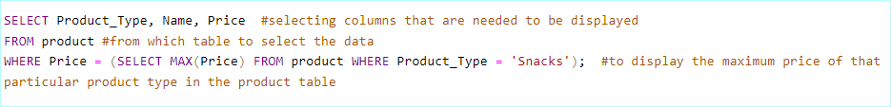

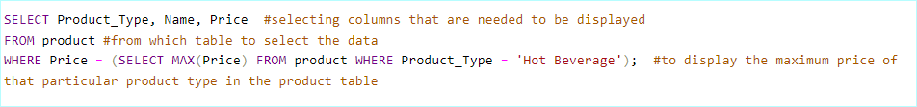

OUTPUT



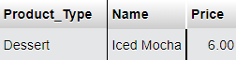







**PART E**

SQL QUERY

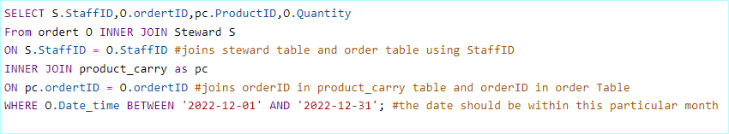

OUTPUT

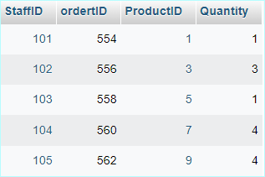

**--------------------End----------------**